**PROGRAM CODE:**

#include<stdio.h>

int safety(int p,int r,int finish[],int available[],int allocation[][r],int request[][r])

{

int j,k,flag,cnt=0;

while(cnt!=p)

{

flag=0;

for(k=0;k<p;k++)

{

if (finish[k]==0)

{

for(j=0;j<r;j++)

if(request[k][j]>available[j])

break;

if(j==r)

{

for(j=0;j<r;j++)

available[j]+=allocation[k][j];

finish[k]=1;

cnt++;

flag=1; //there exists a process that can be satisfied

}

} //end if finish

}//end for

if(flag==0)

return flag;

} //end while

return flag;

}

void main()

{

int p,r,safe,i,j,k;

printf("\t\tDEADLOCK DETECTION \n");

printf("\nEnter the no.of processes: ");

scanf("%d",&p);

printf("\nEnter the no.of resources: ");

scanf("%d",&r);

int available[r],request[p][r],allocation[p][r],finish[p];

for(k=0;k<p;k++)

finish[k]=0;

printf("\nEnter the currently available no.of instances for each resource: \n");

for(i=0;i<r;i++)

{

printf("Resource %c: ",i+65);

scanf("%d",&available[i]);

}

printf("\nEnter the allocated no.of resources for each process: ");

for(i=0;i<p;i++)

{

printf("\nFor P%d: \n",i+1);

for(j=0;j<r;j++)

{

printf("Resource %c: ",j+65);

scanf("%d",&allocation[i][j]);

}

}

printf("\nEnter the request for each process: ");

for(i=0;i<p;i++)

{

printf("\nFor P%d: \n",i+1);

for(j=0;j<r;j++)

{

printf("Resource %c: ",j+65);

scanf("%d",&request[i][j]);

}

}

safe=safety(p,r,finish,available,allocation,request);

if(safe==0)

{

printf("\nSystem is in deadlocked state");

printf("\nProcesses involved in deadlock are: ");

for(k=0;k<p;k++)

if(finish[k]==0)

printf("P%d ",k);

printf("\n");

}

else

printf("\nNo deadlock\n");

}

**OUTPUT:**

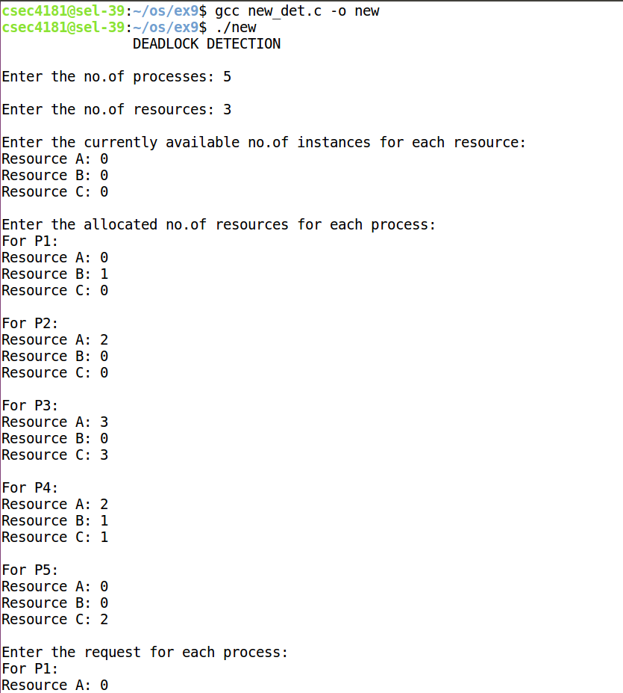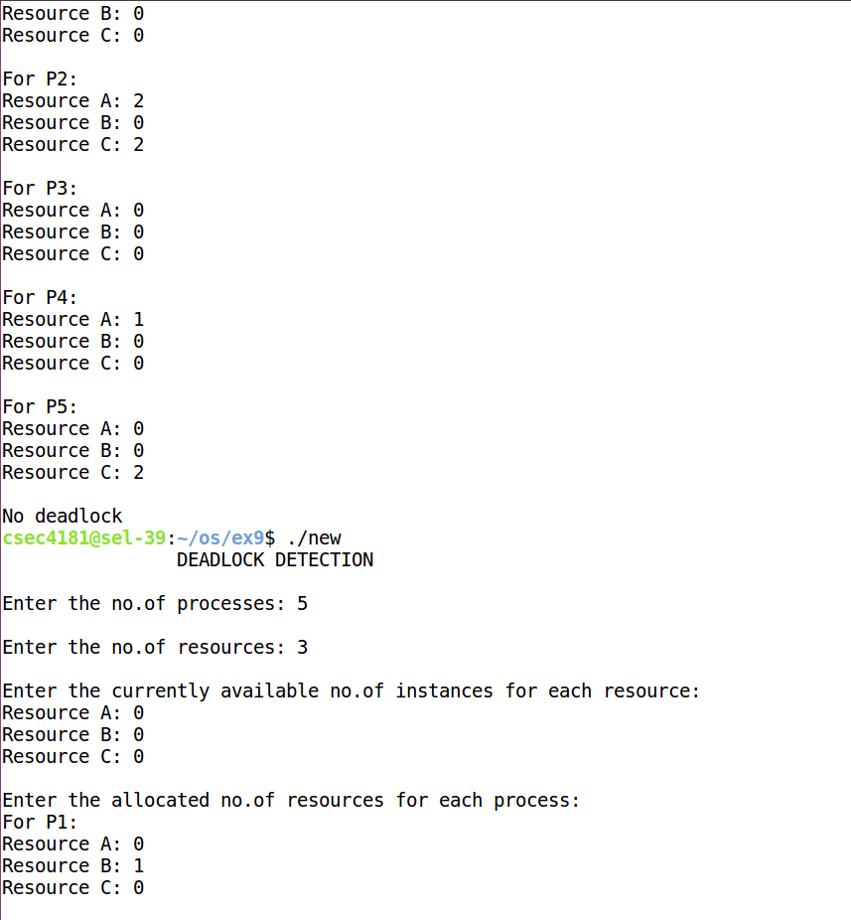



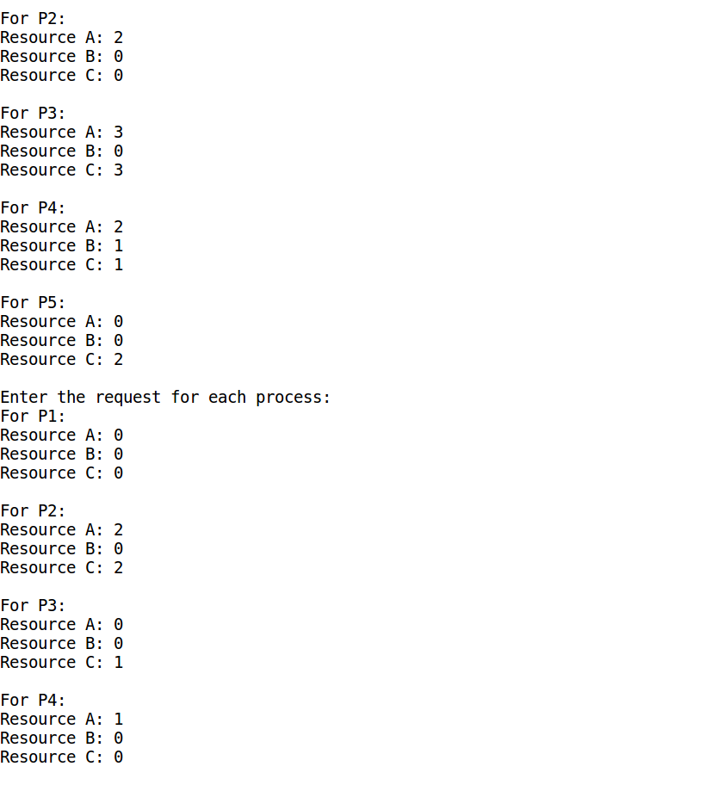

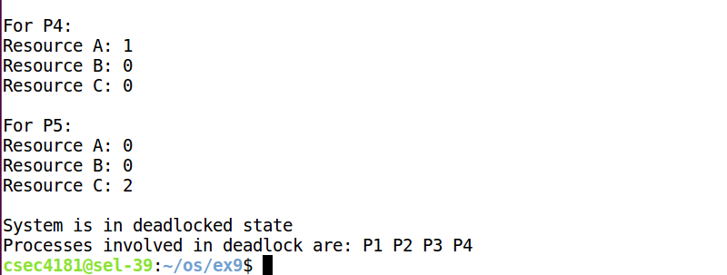

**PROGRAM CODE:**

#include <pthread.h>

#include <stdio.h>

#include <stdlib.h>

#include <math.h>

struct input

{

char **data;

int count;

}in;

float avg=0.0,median,sd;

int min,max; /* this data is shared by the thread(s) */

void *worker_avg(void *param)

{

struct input *t=(struct input *)param;

int i,sum = 0;

for (i = 0; i < t->count; i++)

sum += atoi(t->data[i]);

avg=(float)sum/(t->count-1);

pthread_exit(0);

}

void *worker_min(void *param)

{

struct input *t=(struct input *)param;

int i;

min = atoi(t->data[1]);

for (i = 2; i < t->count; i++)

if (atoi(t->data[i])<min)

min=atoi(t->data[i]);

pthread_exit(0);

}

void *worker_max(void *param)

{

struct input *t=(struct input *)param;

int i;

max = atoi(t->data[1]);

for (i = 2; i < t->count; i++)

if (atoi(t->data[i])>max)

max=atoi(t->data[i]);

pthread_exit(0);

}

void *worker_median(void *param)

{

struct input *t=(struct input *)param;

int i,j,n=t->count;

char * temp;

for(i = 1;i < n-1;i++) //sort

{

for(j = 1;j < n-i-1;j++)

{

if(atoi(t->data[j]) > atoi(t->data[j+1]))

{

temp=t->data[j];

t->data[j]=t->data[j+1];

t->data[j+1]=temp;

}

}

}

if((n-1)%2==0)

{ median=(float) ( atof(t->data[n/2]) + atof(t->data[(n+1)/2]) ) /2; }

else

median=atof(t->data[n/2]);

pthread_exit(0);

}

void *worker_sd(void *param)

{

struct input *t=(struct input *)param;

int arr[t->count-1] , i;

float average,sum=0;

for(i=0;i<t->count-1;i++)

arr[i]=atoi(t->data[i+1]);

for (i = 0; i < t->count-1; i++)

sum += arr[i];

average=(float)sum/(t->count-1);

sum=0;

for (i = 0; i < t->count-1; i++)

sum+=(float)pow((arr[i]-average),2);

sd=(float)sqrt(sum/(t->count-1));

pthread_exit(0);

}

void main(int argc, char *argv[])

{

pthread_t tid1,tid2,tid3,tid4,tid5; /* the thread identifier */

pthread_attr_t attr; /* set of thread attributes */

/* get the default attributes */

pthread_attr_init(&attr);

/* create the thread */

in.data=argv;

in.count=argc;

pthread_create(&tid1,&attr,worker_avg,&in);

pthread_create(&tid2,&attr,worker_min,&in);

pthread_create(&tid3,&attr,worker_max,&in);

pthread_create(&tid4,&attr,worker_median,&in);

pthread_create(&tid5,&attr,worker_sd,&in);

/* wait for the thread to exit */

pthread_join(tid1,NULL);

pthread_join(tid2,NULL);

pthread_join(tid3,NULL);

pthread_join(tid4,NULL);

pthread_join(tid5,NULL);

printf("Avg = %.2f\n",avg);

printf("Min = %d\n",min);

printf("Max = %d\n",max);

printf("Median = %.2f\n",median);

printf("Standard Deviation =%.2f\n",sd);

}

**OUTPUT:**

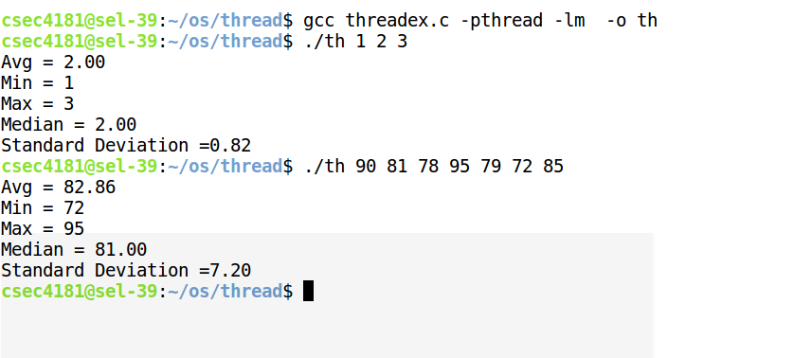

**PROGRAM CODE:**

#include<stdio.h>

#include<stdlib.h>

typedef struct PageTable pagetable;

int pgsize, phy_size;

int no_of_frames, noff; //noff-no of free frames

int frames[100];

struct PageTable

{

int pgno;

int fr_no;

pagetable* next;

};

pagetable* process[10];

void display_table(pagetable *head)

{

for(pagetable *temp = head; temp != NULL; temp = temp->next)

printf("Page %d: Frame %d\n", temp->pgno, temp->fr_no);

printf("\n");

}

void allocate()

{

int i,pid, mem_req, no_of_pages,fr_idx=0;

pagetable *head, *temp, *prev;

printf("\nEnter the process ID: ");

scanf("%d", &pid);

printf("Enter the memory required for the process in KB: ");

scanf("%d", &mem_req);

no_of_pages = mem_req/pgsize;

if(mem_req%pgsize!=0)

no_of_pages++;

printf("\nProcess is divided into %d pages.\n", no_of_pages);

if(no_of_pages>noff)

{

printf("Not available!\n");

return;

}

for(i=0;i<no_of_pages;i++)

{

temp = (pagetable*)malloc(sizeof(pagetable));

temp->pgno = i;

while(frames[fr_idx]==0) fr_idx++; //frame not free

temp->fr_no = fr_idx;

frames[fr_idx]=0; //frame occupied

fr_idx++;

temp->next = NULL;

noff--;

if(i==0)

head = temp;

else

prev->next = temp;

prev = temp;

}

process[pid] = head;

printf("Page Table for process ID: %d\n", pid);

display_table(process[pid]);

}

void deallocate()

{

pagetable *pd, *temp, *d;

int pid;

printf("Enter the process id to deallocate:");

scanf("%d", &pid);

temp = process[pid];

if(temp==NULL)

{

printf("Not allocated!\n");

return;

}

while(temp!=NULL)

{

d = temp;

frames[d->fr_no]=1; //frame is made free

noff++;

temp = temp->next;

free(d);

}

process[pid] = NULL;

printf("Deallocated!\n");

}

void display_all()

{

int i;

for(i = 0; i < 10; i++)

if(process[i] != NULL)

{ printf("Page Table for process ID: %d\n", i);

display_table(process[i]);

}

}

void display_free_frames()

{

int i;

for(i=0;i<no_of_frames;i++)

if(frames[i]==1) printf("%d ", i);

printf("\n");

}

void addressmap()

{

int i,pid, la, page_no,offset,frame_no, pa;

pagetable *h , *temp;

printf("Enter the process id: ");

scanf("%d", &pid);

printf("Enter the logical address: ");

scanf("%d", &la);

page_no = la / (pgsize * 1024);

offset = la % (pgsize * 1024);

temp=process[pid];

for(i = 0; i < page_no; i++) //find the page

temp = temp->next;

frame_no = temp->fr_no;

pa = (frame_no * pgsize * 1024 )+ offset; //frame size=page size

printf("Physical address: %d\n", pa);

}

void main()

{

int i,fr,ch=0;

for(i=0;i<100;i++) frames[i]=0; //frame free

printf("\n\tPAGING TECHNIQUE");

printf("\n\nEnter physical memory size in KB: ");

scanf("%d", &phy_size);

printf("Enter the page size in KB: ");

scanf("%d", &pgsize);

no_of_frames = phy_size / pgsize; //page size =frame size

printf("Physical memory is divided into %d frames.\n", no_of_frames);

for(i = 0; i < no_of_frames/2; i++) //half of the frames are free

{

fr = random()%no_of_frames;

if(frames[fr] != 1)

{

frames[fr] = 1;

noff++;

}

else //if same no is being generated again

i--;

}

do

{

printf("\n1.Process Request\n2.Deallocate\n3.Page Table display for all input process\n4.Free Frame list display\n5.Address Mapping\n6.Exit\n\nEnter your choice: ");

scanf("%d", &ch);

switch(ch)

{

case 1:

allocate(); break;

case 2:

deallocate(); break;

case 3:

display_all(); break;

case 4:

display_free_frames(); break;

case 5:

addressmap(); break;

case 6:

exit(0);

}

}while(1);

}

**OUTPUT:**

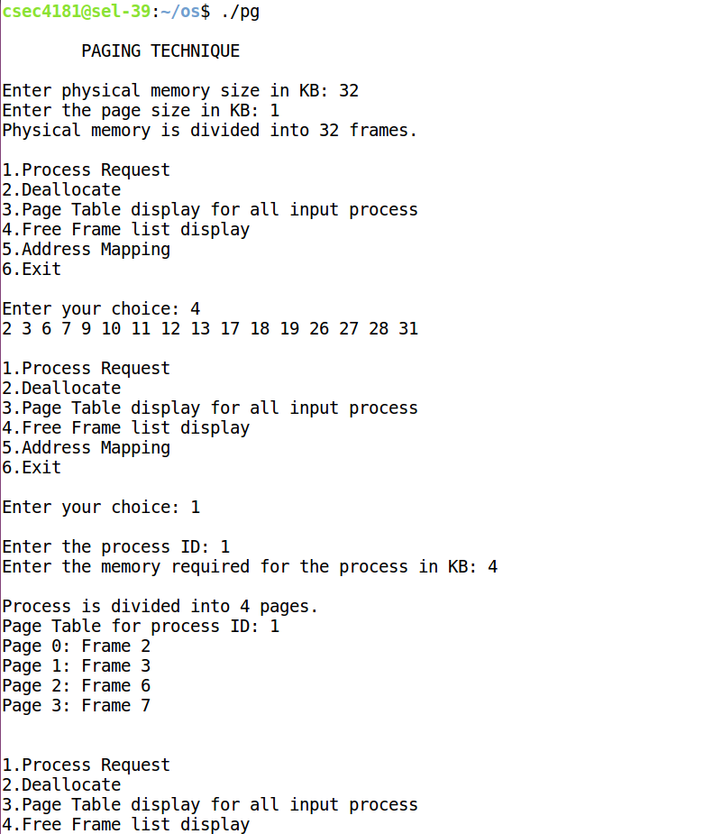



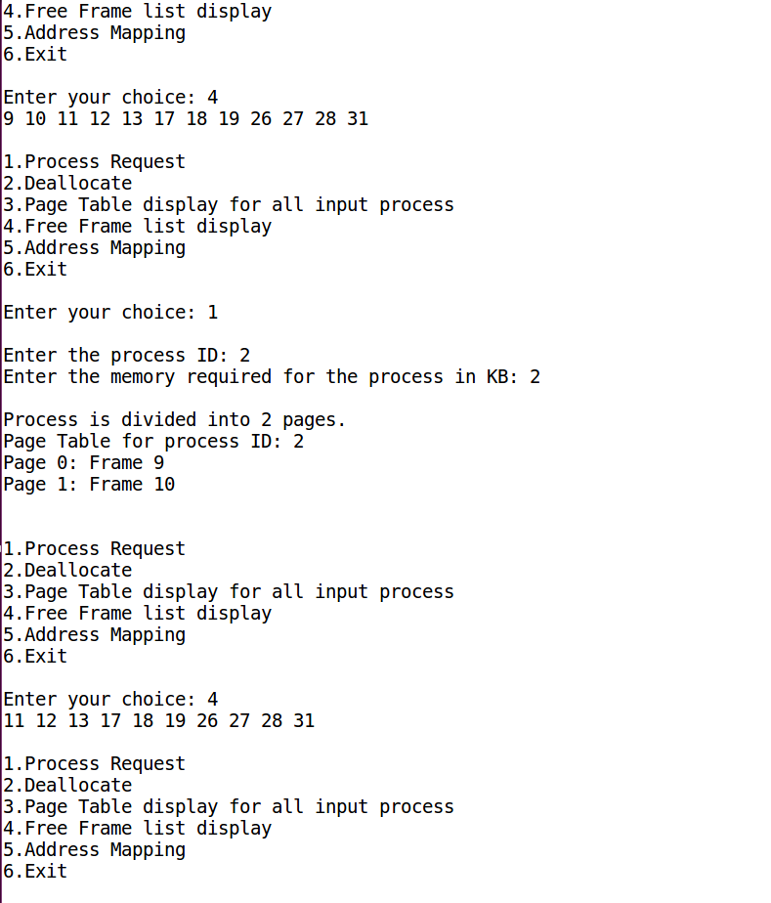

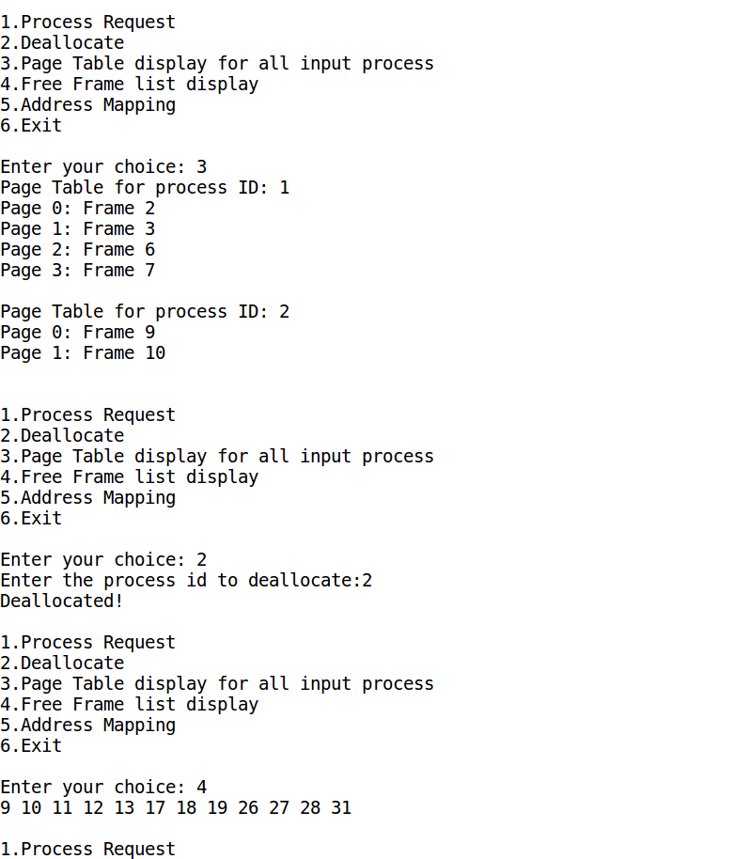

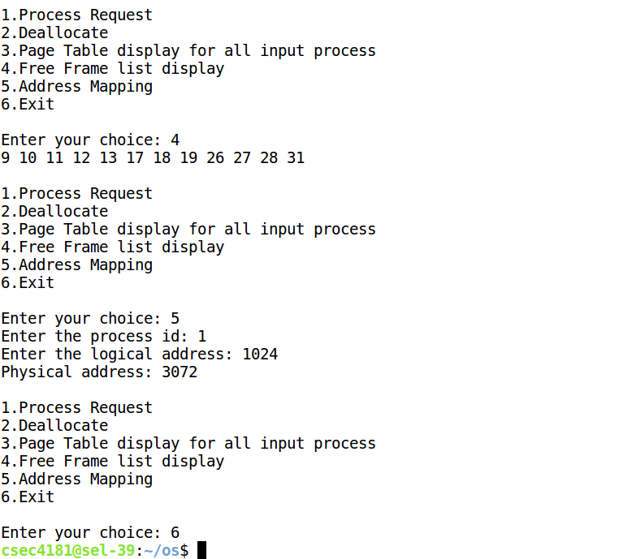

**PROGRAM CODE:**

#include<stdio.h>

#include<stdlib.h>

int find(int ref_string, int *frames, int frames_req)

{

for(int i=0;i<frames_req;i++)

{

if(ref_string==frames[i])

return 1;

}

return 0;

}

int find_not_recently_used(int *ref_string, int n,int *frames, int frames_req, int curr)

{

int cnt[frames_req],max,i;

for(i=0;i<frames_req;i++)

{

cnt[i]=0;

for(int j=curr-1;j>=0;--j)

{

if(frames[i]==ref_string[j])

break;

++cnt[i];

}

}

max=cnt[0];

curr=0;

i=1;

while(i!=frames_req)

{

if(cnt[i]>max)

{

max=cnt[i];

curr=i;

}

++i;

}

return curr;

}

int find_not_req_next(int *ref_string, int n,int *frames, int frames_req, int curr)

{

int cnt[frames_req],max,i;

for(i=0;i<frames_req;i++)

{

cnt[i]=0;

for(int j=curr+1;j<n;j++)

{

if(frames[i]==ref_string[j])

break;

++cnt[i];

}

}

max=cnt[0];

curr=0;

i=1;

while(i!=frames_req)

{

if(cnt[i]>max)

{

max=cnt[i];

curr=i;

}

++i;

}

return curr;

}

void FIFO(int frames_req, int *ref_string, int n)

{

printf("\n\n\tFIFO ALGORITHM\n\n");

int ptr=-1, pg_fault=0,cnt,i;

int frames[frames_req];

for(cnt=0;cnt<frames_req;cnt++)

{

frames[cnt]=ref_string[cnt];

++pg_fault;

printf("Page fault in inserting page %d - ",ref_string[cnt]);

for(int j=0;j<frames_req;j++)

if(j>cnt)

printf("X ");

else

printf("%d ",frames[j]);

printf("\n");

}

while(cnt!=n)

{

i=find(ref_string[cnt], frames,frames_req);

if(i==0)//not available

{

++pg_fault;

if(ptr+1!=frames_req)

++ptr;

else

ptr=0;

frames[ptr]=ref_string[cnt];

printf("Page fault in inserting page %d - ",ref_string[cnt]);

for(int j=0;j<frames_req;j++)

printf("%d ",frames[j]);

printf("\n");

}

++cnt;

}

printf("\nTotal no of page faults = %d\n",pg_fault);

}

void optimal(int frames_req, int *ref_string, int n)

{

printf("\n\n\tOPTIMAL ALGORITHM\n\n");

int ptr=0, pg_fault=0,cnt,i;

int frames[frames_req];

for(cnt=0;cnt<frames_req;cnt++)

{

frames[cnt]=ref_string[cnt];

++pg_fault;

printf("Page fault in inserting page %d - ",ref_string[cnt]);

for(int j=0;j<frames_req;j++)

if(j>cnt)

printf("X ");

else

printf("%d ",frames[j]);

printf("\n");

}

while(cnt!=n)

{

i=find(ref_string[cnt], frames,frames_req);

if(i==0)//not available

{

++pg_fault;

ptr=find_not_req_next(ref_string,n,frames,frames_req,cnt);

frames[ptr]=ref_string[cnt];

printf("Page fault in inserting page %d - ",ref_string[cnt]);

for(int j=0;j<frames_req;j++)

printf("%d ",frames[j]);

printf("\n");

}

++cnt;

}

printf("\nTotal no of page faults = %d\n",pg_fault);

}

void LRU(int frames_req, int *ref_string, int n)

{

printf("\n\n\tLEAST RECENTLY USED ALGORITHM\n\n");

int ptr=0, pg_fault=0,cnt,i;

int frames[frames_req];

for(cnt=0;cnt<frames_req;cnt++)

{

frames[cnt]=ref_string[cnt];

++pg_fault;

printf("Page fault in inserting page %d - ",ref_string[cnt]);

for(int j=0;j<frames_req;j++)

if(j>cnt)

printf("X ");

else

printf("%d ",frames[j]);

printf("\n");

}

while(cnt!=n)

{

i=find(ref_string[cnt], frames,frames_req);

if(i==0)//not available

{

++pg_fault;

ptr=find_not_recently_used(ref_string,n,frames,frames_req,cnt);

frames[ptr]=ref_string[cnt];

printf("Page fault in inserting page %d - ",ref_string[cnt]);

for(int j=0;j<frames_req;j++)

printf("%d ",frames[j]);

printf("\n");

}

++cnt;

}

printf("\nTotal no of page faults = %d\n",pg_fault);

}

void main()

{

int i,fcnt=-1,noff, frames, ref_string[20], n=0,choice;

printf("************ PAGE REPLACEMENT *************");

do

{

printf("\n\n\tMENU:\n1.Read Input\n2.FIFO\n3.Optimal\n4.LRU\n5.Exit\nEnter choice: ");

scanf("%d",&choice);

switch(choice)

{

case 1:

printf("Enter the number of free frames: ");

scanf("%d",&noff);

printf("Enter the number of frames required by the process: ");

scanf("%d",&frames);

if(noff<frames)

{

printf("No of frames required is greater than free frames available!");

exit(1);

}

printf("Enter the reference string:\n");

do

{

scanf("%d",&ref_string[++fcnt]);

}while(ref_string[fcnt]!=-1);

break;

case 2: FIFO(frames,ref_string,fcnt); break;

case 3: optimal(frames,ref_string,fcnt); break;

case 4: LRU(frames,ref_string,fcnt); break;

case 5: break;

default: printf("\nInvalid choice ");

}

}while(choice!=5);

}

**OUTPUT:**

